[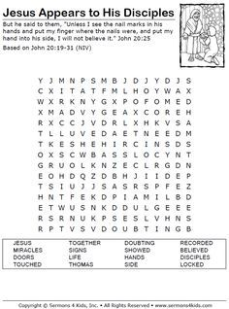](https://www.google.co.uk/url?sa=i&url=https://www.pinterest.com/pin/249105423115916262/&psig=AOvVaw0auG6erQ9zAoLOn8b2ELim&ust=1587212867307000&source=images&cd=vfe&ved=0CAIQjRxqFwoTCOil8-u67-gCFQAAAAAdAAAAABAD)