[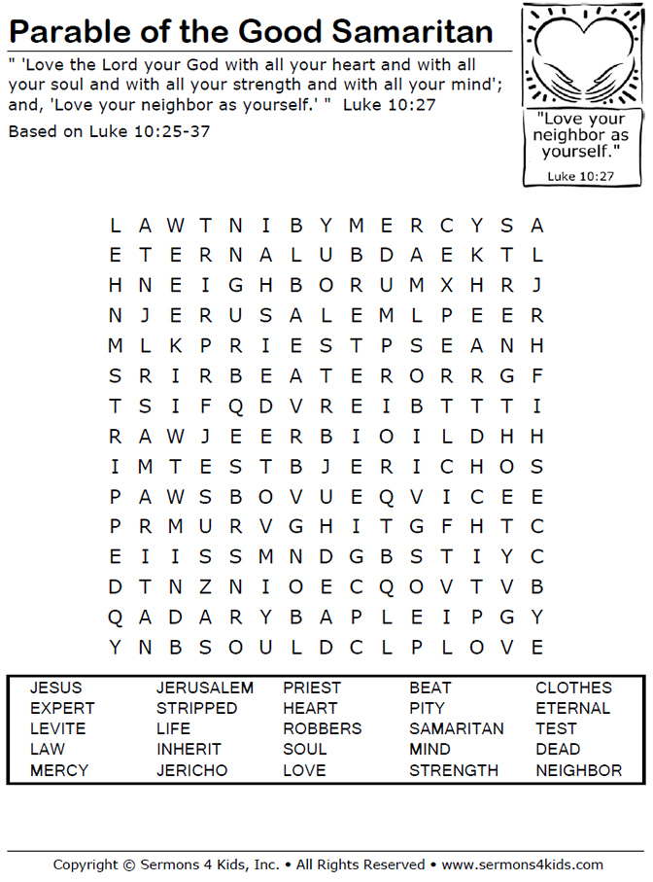](https://www.google.com/url?sa=i&url=https://sermons4kids.com/good_samaritan_wordsearch.htm&psig=AOvVaw2Km2FWnXTR9h7ZWND8tuLc&ust=1594469434446000&source=images&cd=vfe&ved=0CAIQjRxqFwoTCPCu6eLTwuoCFQAAAAAdAAAAABAD)