[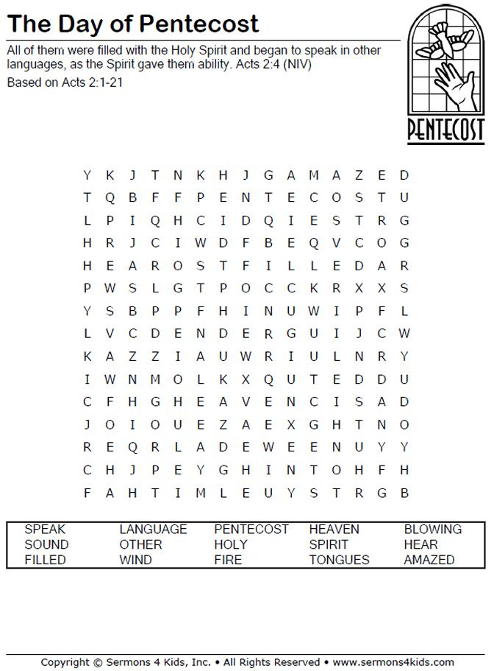](https://www.google.co.uk/url?sa=i&url=https://www.pinterest.com/pin/136233957448286584/&psig=AOvVaw3eTnBQNO3HRP8xk5BmMliQ&ust=1590687298061000&source=images&cd=vfe&ved=0CAIQjRxqFwoTCNjU_JbK1OkCFQAAAAAdAAAAABAP)