[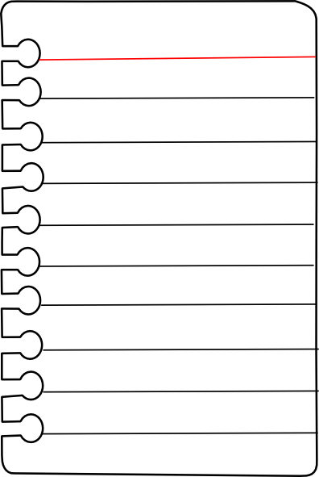](https://www.google.co.uk/url?sa=i&url=https://www.pinterest.com/pin/559924166142061700/&psig=AOvVaw386qTUwjgJYIUq3PUTOlC7&ust=1590239987761000&source=images&cd=vfe&ved=0CAIQjRxqFwoTCNDJ0-fHx-kCFQAAAAAdAAAAABAD)

My questions…

**Special Agent Service notes.**

**Date……………………………………………….**

**Theme…………………………………………..**

[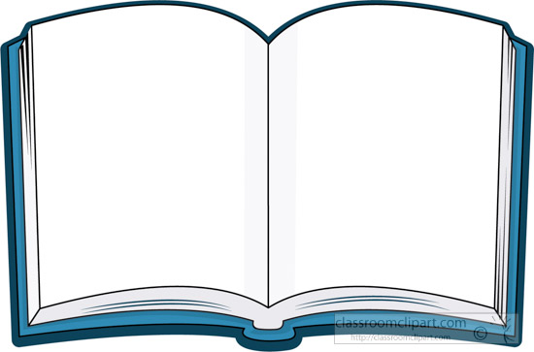](https://www.google.co.uk/url?sa=i&url=https://animaloilmaker.com/explore/book-clipart-teal.html&psig=AOvVaw1bq6c-K1bZorzkiBLL3fS_&ust=1590252651613000&source=images&cd=vfe&ved=0CAIQjRxqFwoTCIjRjf72x-kCFQAAAAAdAAAAABAD)

Book…

Chapter

Verse

Bible Reading

**Words I heard, but don’t know.**

[](https://www.google.co.uk/url?sa=i&url=https://www.pinterest.com/pin/506021708112482982/&psig=AOvVaw1YLudhtECNESQUKNjMrjKB&ust=1590240171251000&source=images&cd=vfe&ved=0CAIQjRxqFwoTCLj1zrjIx-kCFQAAAAAdAAAAABAF)

Important information I heard about God

Wow idea…

How does this change me?