[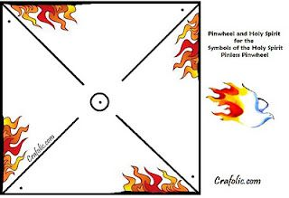](https://www.google.co.uk/url?sa=i&url=https://www.pinterest.com/pin/215328425903934915/&psig=AOvVaw2jN_Va5mfvjpTgYDf6U5Kd&ust=1590836974240000&source=images&cd=vfe&ved=0CAIQjRxqFwoTCIDImNj32OkCFQAAAAAdAAAAABAU)