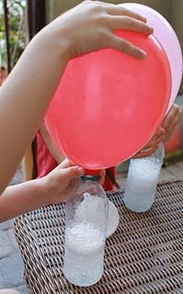
Experiment 1: The Holy Spirit fills us.

You will need…
A balloon
Bicarbonate of soda/baking powder
Vinegar
A bottle

Put some vinegar in the bottle.
Add some baking powder.
Quickly put the balloon over the neck of the bottle and watch it inflate.
Just like the Holy Spirit fills you!

Experiment 2: The Holy Spirit fills us with power.
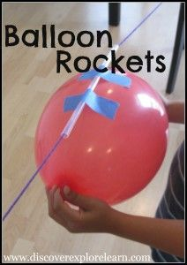
Materials:
Balloons
Yarn (cut to about 6 feet)
Straw
Tape
Tie one end of the yarn to the back of a chair.
Next, thread a drinking straw onto the other end of the yarn, and then tied it to the second chair.
After attaching two pieces of tape (about 2 inches in length each) to the centre of the straw, it was time for the real fun to begin.
Inflate the balloon (leaving the end untied), hold onto the opening so the air won’t escape, and carefully attach it to the tape and straw. Then let go of the balloon.
Why not have a balloon rocket race!

